BCS 3101: Basics of Machine Learning

Notebook 4 Report: Feature Scaling and Data Transformation
Student Name: NIYONSHUTI MERCY
Registration Number: 2025/A/KCS/6117/F
Group Project: Predicting Monthly Maize and Beans Prices in Selected Ugandan Markets

This report explains the actions done in Notebook 4. The notebook belongs to Stage 8 of the project, which is called Data Pre-processing III Data Transformation.
The main work in this notebook was to prepare the encoded dataset for machine learning by checking the scale of features, applying scaling methods, and testing a log transform on the target variable.
The goal was to make sure the model will not be dominated by large-valued variables such as price columns while still keeping the original meaning of the prediction target.

1. What the dataset looked like
The dataset loaded successfully with 1652 rows and 23 columns. This means the file was ready for transformation and analysis.
The selected variables included price variables such as maize and beans prices, market variables, time variables, geographic variables, and several quality or coverage indicators. These columns were already prepared from the earlier encoding stage, so the work here focused on scale adjustment and transformation.

2. Why scaling was necessary
Feature scaling is important because machine learning algorithms are sensitive to the size of the numbers used in the model.
If one feature has values in thousands, while another feature is only between 0 and 12, the larger feature can dominate the learning process even when it is not more important.
This is especially true for distance-based methods and algorithms using gradient descent. In short, scaling makes all features comparable before the model learns from them.
In this notebook, the price columns like c_maize and c_beans were much larger than the month and location values. Without scaling, the model might focus too much on price size instead of the real pattern in the data.
Method | Main idea | What it does | Why it was used here
Min-Max Scaling | Rescales values into a fixed range | Values are mapped between 0 and 1 | Shown to explain how the feature range changes but not chosen for the final model
Z-score Standardisation | Centre values around zero and divide by standard deviation | Each feature gets mean close to 0 and standard deviation close to 1 | Chosen as the preferred scaling method because it is more robust to large price values
Log transform | Compresses large positive values | Makes a skewed distribution more balanced | Used on the target price to reduce right-skew and improve interpretation

3. What was done in the notebook
1. The notebook loaded the encoded CSV file that was produced in the previous notebook.
2. It checked the number of rows and columns to confirm the dataset was ready for the next stage.
3. It selected the main numeric columns for inspection.
4. It compared the scales of variables such as maize price, beans price, month, latitude, and longitude.
5. It applied Min-Max scaling to show how values are compressed into a fixed range.
6. It applied StandardScaler to standardise the features to a zero-mean and unit-variance form.
7. It applied a log transform to the maize and beans target prices so the distribution could be analysed more clearly.
8. It saved the transformed data so that the next notebook could continue with splitting, reduction, and model training.

4. Reason for the final decision
The notebook finally selected StandardScaler for the feature variables.
This decision was made because the price columns contained genuine high values and the data was not evenly scaled. Min-Max scaling can be sensitive to extreme values because it depends on the minimum and maximum values of the dataset.
StandardScaler is usually more practical when a dataset contains outliers or a wide range of values. It keeps the data centred and reduces the effect of one very large feature on the whole model.
For this project, this was a useful step because the dataset contains price values in local currency and also other variables measured on a smaller scale.

5. Example visual summary
The figure below shows the original distribution of maize prices and the log-transformed version. The log transformation reduces the influence of extreme high values and makes the distribution easier to study.
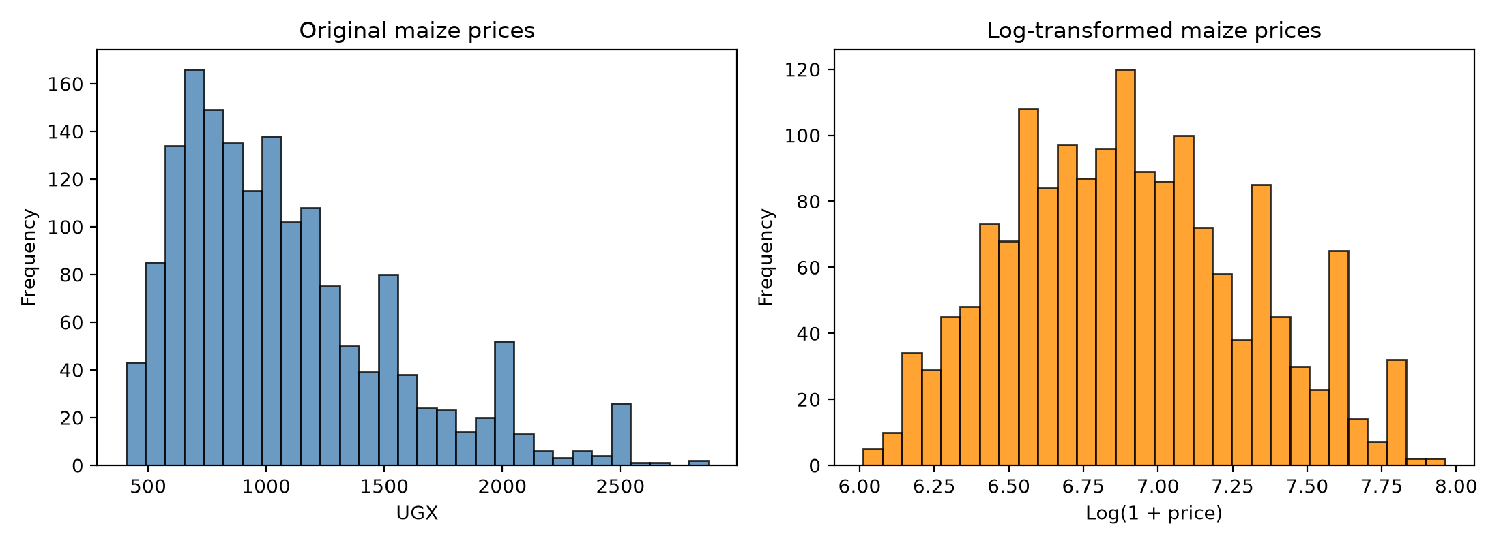
Feature | Typical scale | Effect if not scaled
c_maize | Large values in UGX | Dominates the model due to its size
month | Small integer range (1 to 12) | Often ignored if not normalised
lat / lon | Small continuous values | Can be overshadowed by stronger price features

6. Why this matters for the machine learning pipeline
This notebook is a very important part of the full project because the next steps in the pipeline depend on correctly prepared features.
If scaling is done properly, learning becomes more stable. If scaling is ignored, the model may produce poor results or give misleading importance to the wrong variables.
This is why the notebook also carefully reminds us that scaling must be fitted only on the training data when the final model is built. That is a standard rule for avoiding data leakage during evaluation.

7. Conclusion
In Notebook 4, the team looked at the encoded market dataset and prepared it for the next modelling stage. The notebook showed that the prices had very different scales from other features, explained why scaling is necessary, and applied both Min-Max scaling and StandardScaler. It also demonstrated a log transformation for the target variable. The final decision was to use StandardScaler for the main feature set while keeping the target in its original units for easier interpretation.

